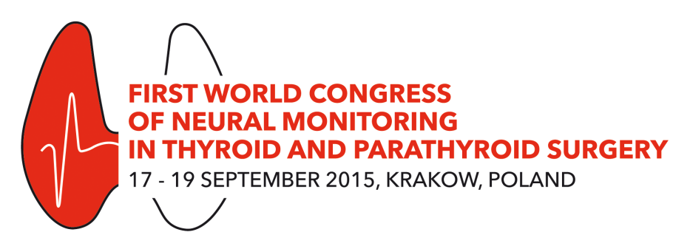
PROGRAM AT A GLANCE
Congress Venue: Audytorium Maximum UJ, 33 Krupnicza Street, Krakow
17 September 2015, Thursday
Time | Location
 | Large Hall A+B | Medium Hall A+B |  | Small Hall |  |  | Seminar Room
08:00 – 10:00 |  |  |  |  |  |  | Instructional course (1)  LARYNGOSCOPY HANDS ON STATIONS  in cooperation with STORZ
10:00 – 10:30 | Coffee Break
10:30 – 12:30 |  |  |  |  |  |  | Instructional course (2)  LARYNGEAL ULTRASOUND HANDS ON STATIONS in cooperation with SAMSUNG
12:30 – 13:30 | Lunch Time (Exhibition Room)
13:30 – 15:30 |  | Instructional course (3): Standardized IONM technique: part 1 (basic):15min each |  | A Sattelite Symposium: IONM in nerve-sparing rectal cancer surgery – Co-organized by the Polish Club of Coloproctology: 20 min each
15:30 – 16:00 | Coffee Break (Exhibition Room)
16:00 – 18:00 |  | Instructional course (4): Standardized IONM technique: part 2 (advanced) |  | Instructional course (5): Standards of anesthesia for IONM” (for anesthetists)
18:00 – 18:15 | Coffee Break (Exhibition Room)
18:15 – 19:15 | OPENING CEREMONY  Introductory lecture: (15min)  INTERNATIONAL NEURAL MONITORING STUDY GROUP  Gregory W. Randolph, USA  Key-note lecture 1: (30min)  THE QUANTUM LEAP OF ELECTROPHYSIOLOGIC NERVE MONITORING IN THYROID SURGERY  Henning Dralle, Germany
19:15 – 19:45 | Marcin Wyrostek COLORIAGE Music Band Show
20:00 – 22:00 | Welcome Reception  Given by the Mayor of the City of Krakow, Town Hall, 3/4 Plac Wszystkich Świętych
18 September 2015, Friday
Time | Location
 | Large Hall A |  | Medium Hall A+B |  |  | Small Hall
07:15 – 07:45 | Basic definitions in IONM: (30min)
07:45 – 08:00 | Coffee Break (Exhibition Room)
08:00 – 08:30 | Key-note lecture 2: (30min)  LARYNX, VOICE AND IONM – AN ELECTOPHYSIOLOGIC PERSPECTIVE  Gregory W. Randolph, USA |  | Protected time slot |  |  | Protected time slot
08:30 – 09:00 | Key-note lecture 3: (30min)  COST-EFFECTIVENESS ANALYSIS OF IONM IN THYROID SURGERY  Gianlorenzo Dionigi, Italy |  | Protected time slot |  |  | Protected time slot
09:00 – 09:30 | Coffee Break and a Poster Walk (Exhibition Room)
09:30 – 11:30 | Panel 1: (6min each)  AROUND THE WORLD WITH IONM |  | Protected time slot |  |  | Protected time slot
11:30 – 12:30 | Mini-symposium 1: (15min each)  IONM IN ENDOSCOPIC THYROIDECTOMY |  | Oral Paper Session 1 – Best Abstracts (1-6) |  |  | Mini-symposium 2: (15min each)  ALL YOU NEED TO KNOW ABOUT VAGAL NERVE DISSECTION
12:30 – 13:30 | Lunch Time & Meet the Professor: Hanning Dralle, Gregory W. Randolph, Feng-Yu Chiang, Gianlorenzo Dionigi and Marcin Barczyński (Exhibition Room)
13:30 – 14:30 | Sponsor Session: Dr. Langer, Inomed, Medtronic (Large Hall A)
14:30 – 16:00 | Panel 2: (15min each)  INTERMITTED IONM – Evidence based perspective |  | Video Session 1 (1-8): 10min each |  |  | Oral Paper Session 2 (7-15): 10min each
16:00 – 16:30 | Coffee Break and a Poster Walk (Exhibition Room)
16:30 – 18:00 | Panel 3: (15min each)  CONTINEOUS IONM – Evidence based perspective |  | Video-session 2 (9-16): 10min each |  |  | Oral Paper Session 3 (16-24): 10min each
20:00 – 23:00 | Gala Dinner  Art Gallery of the Polish Paintings of the 19th Century, 1/3 Rynek Główny
19 September 2015, Saturday
Time | Location
 | Large Hall A |  | Medium Hall A+B |  | Small Hall
08:15 – 10:00 | Panel 4: (15min each)  LOSS OF SIGNAL AND STAGED THYROIDECTOMY |  | Oral Paper Session 4 (25-35): 10min each |  | Oral Paper Session 5 (36-45): 10min each
10:00 – 10:30 | Coffee Break and a Poster Walk (Exhibition Room)
10:30 – 11:00 | Key-note lecture 4: (30min)  MANAGEMENT OF THE SLN DURING THYROIDECTOMY IN THE ERA OF IONM  Speaker: Marcin Barczyński, Poland |  | Protected time slot |  | Protected time slot
11:00 – 12:00 | Mini-symposium 3: (20min each)  EXPERIMENTAL ANIMAL MODELS FOR RLN INJURY |  | Mini-symposium 4: (20min each) |  | Oral Paper Session 6 (46-51): 10min each
12:00 – 13:00 | Lunch Time and a Poster Walk ( Exhibition Room)
13:00 - 14:30 | Panel 5: (20min each)  INFORMED CONSENT AND MALPRACTICE LITIGATION |  | Video Session 3 (17-22): 10min each |  | Oral Paper Session 7 (52-60): 10min each
14:30 – 16:00 | Closing Remarks followed by the Meeting of the International Neural Monitoring Study Group
ALL Posters SHOULD be presented during a Poster Walk, which is scheduled to take place during the coffee breaks

